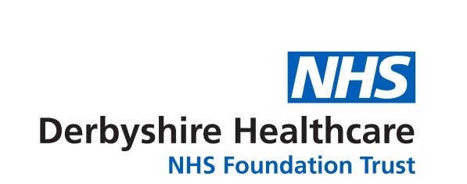

Entry Form – Writing Competition
‘Finding my calm during Covid’
Name of person submitting the entry:
Address (including postcode):

Telephone:
Email:

Age category: under 18 years 18 years and over (including adults)

Are you a: service user carer Trust member staff

governor volunteer other (please specify)

I understand that by entering this competition I give consent to Derbyshire Healthcare to use my name and/or entry in any publicity material and that it will be attributed to me unless I ask to remain anonymous. I understand that the copyright of the entry will remain with me.

Please tick this box if you do not want your name to be used and wish to remain anonymous.

By signing this form I am confirming that the entry is my original work, that I am the author and that I am over 18 years of age.

Name of entry:
Signature:
Date:

The author is under 18. I give my consent as parent/guardian:

(Name):
(Signature):
For guidance on how to enter, please see overleaf.
The closing date is midnight on Friday 2 July 2021.

Writing Competition Guidance
‘Finding my calm during Covid’

- The competition is organised by Derbyshire Healthcare NHS Foundation Trust.
- Entry to this competition is open to Trust members, service users, carers, Trust staff, stakeholders, partner organisations and the voluntary sector.
- The Trust, along with the Council of Governors, is inviting people to share their experience of how they have coped during the COVID-19 pandemic – and at the same time help raise awareness of our services and challenge health stigmas. The last year has been challenging for us all – we have been living with COVID-19 and have experienced three lockdowns. Many of us have put coping mechanisms in place to deal with these stressful times. We are keen to share your experiences and celebrate your achievements.
- Entry will be in two age categories – ages up to 18 years and 18 years and over.
- To enter, you must write a piece with the title ‘Finding my calm during Covid’ that is no more than 500 words in length. You can send us a poem, a short story, a diary piece or a blog post, or a letter. The piece of writing must be the original work of the author.
- You can submit a typed or handwritten story. It should be clear and easy to read.
- You must complete the entry form and attach it to your entry.
- Your submission, along with the entry form can be emailed to dhcft.membership@nhs.net or posted to Denise Baxendale (Membership and Involvement Manager), Derbyshire Healthcare NHS Foundation Trust, c/o Executive Directors’ Suite, Ashbourne Centre, Kingsway Hospital, Kingsway, Derby, DE22 3LZ.
- If you would like to find out more please email dhcft.membership@nhs.net or telephone 01332 623723.
- The entries cannot be returned, so please make a copy of your entry before you submit it.
- After the closing date of 2 July 2021, a panel of judges will shortlist the entries. The judges’ decision will be final.
- The winners will be announced at the Trust’s Annual Members’ Meeting on Thursday 9 September. The meeting will take place in the afternoon from 4pm. Due to COVID-19 this meeting will be held digitally via Microsoft Teams, a video conferencing app. We will contact the shortlisted writers in advance of the meeting and invite them to attend, and we will do our best to support the shortlisted writers to join the meeting. However we cannot unfortunately provide any IT equipment for this purpose.
- Prizes (national book vouchers) will be posted to the winners after 9 September 2021.
- The shortlisted entries will be featured on the Trust’s website; in Trust publications; and in a booklet produced in-house.
- By entering the competition, you keep your copyright but you give permission to Derbyshire Healthcare NHS Foundation Trust to publish your entry and your name on the Trust’s internet and website (including social media).
About your personal information…
Any personal information you share will be used solely for processing your entry to the Trust’s writing competition. All applications will be held securely by Derbyshire Healthcare and we will never share or publish your information without your consent. We take your privacy seriously and promise never to sell your data.

